Tyre Degradation Prediction
In Formula 1 racing sports , tyre management or tyre monitoring is one of the most important part of the race strategy. The tyre rubber wear out over time, resulting in worse grip or traction on road ,thus causing longer lap times and reduced car control. With the “cliff” – which can cost a driver several seconds per lap. Because of this the teams have to make accurate predictions on when to pit, which compound to select and what driving strategy to adopt during a stint.
The current Tyre Degradation models in motorsports depends on simple regression algorithms or historical averages which is unable to capture the constantly changing race conditions in a live race. Shakila and Baalaji identified two key gaps in current methods: (i) lack of advanced ML models that capture the non-linear nature of the data better and (ii) lack of models that can process and deliver results in real time. Metaheuristic approaches like PSO , Genetic Algorithms were used and demonstrated by Gamal et al. , they succeeded in achieving optimal results but required up to 800 seconds of computational time , which is not feasible for a real time model.
The proposed model uses a monotonically constrained XGBoost regressor to predict tyre degradation in real-time, lap by lap. The model is trained on 79,745 clean laps from 92 Grands Prix from 2022–2025 seasons via the FastF1 API. The tyre degradation predictions produced by this model is to be fed into the Monte Carlo Race Simulation Layer, enabling evaluation of pit stop timing and compound strategies under evolving race conditions.
Target Variable: Pace Residual
A key challenge is that raw lap times blends three distinct effects: (i) circuit base pace, (ii) fuel burn (~0.065s/lap improvement as fuel mass decreases), and (iii) tyre degradation. To isolate the degradation signal, a performance-normalised target — the pace residual — is used:
Target_Tyre_Degradation = LapTime − Expected_Non_Tyre_Pace

Expected_Non_Tyre_Pace = Circuit_Base_Pace + Fuel_Weight_Penalty

Fuel_Weight_Penalty = (Total_Race_Laps − Current_Lap) × 0.065
This removes circuit-specific and fuel-related variation, leaving only tyre-attributable performance loss as the modelling target.
Feature Set
12 causally-informed features are used, limited strictly to variables available at prediction time (no future leakage). All temporal features (Lag1_Pace_Residual, Rolling3_Degradation_Trend, Team_Median_Pace_Lag1) are strictly lagged — built only from information available before the current lap.
Feature | Description
TyreAge | Physical age of current tyre set (laps)
Log_TyreAge | log(1 + TyreAge), captures non-linear cliff
StintLap | Lap number within current stint
Compound_Encoded | Ordinal: Soft=1, Medium=2, Hard=3
RaceProgressFraction | LapNumber / TotalLaps
TrackTemp | Track surface temperature (°C)
AirTemp | Ambient air temperature (°C)
is_safety_car | Safety Car deployed this lap (boolean)
is_vsc | Virtual Safety Car active (boolean)
Lag1_Pace_Residual | Previous lap’s pace residual (t−1)
Rolling3_Degradation_Trend | 3-lap rolling slope of residual
Team_Median_Pace_Lag1 | Constructor’s expanding historical median

Model
XGBoost was selected for: (i) strong performance on structured tabular data at this scale, (ii) microsecond-level inference suitable for Monte Carlo simulation, (iii) native monotonic constraint support (enforcing that degradation cannot “heal” with tyre age), and (iv) interpretable feature importance for race engineer review.
Bayesian hyperparameter optimisation (Optuna, 30 trials) was applied with early stopping (patience = 50 rounds), resulting in a compact model (34 boosting rounds, max depth 4). A monotonic increasing constraint on TyreAge prevents the model from learning spurious recovery patterns from transient noise.
Tyre Degradation Prediction Metrics
Model | MAE (s) | RMSE (s) | R² | Bias (s)
Global Mean | 1.258 | 1.714 | −0.077 | −0.460
Linear Reg (TyreAge only) | 1.197 | 1.633 | 0.022 | −0.405
Multiple Linear Regression | 0.940 | 1.482 | 0.195 | −0.001
XGBoost Baseline | 0.424 | 0.719 | 0.841 | 0.035
XGBoost Optimised (Ours) | 0.383 | 0.658 | 0.867 | 0.018

The optimised XGBoost achieves a 59.2% MAE reduction over the best linear baseline, with near-zero systematic bias (+0.018s) — critical for Monte Carlo rollouts where bias accumulates over multi-lap horizons.
The primary improvement over prior work is the combination of a causally-engineered pace residual target with a monotonically constrained gradient boosting model. While traditional approaches model raw lap times and fail to isolate the tyre wear signal, this approach separates fuel, circuit, and degradation effects. The model dynamically captures non-linear degradation patterns, including the cliff, and operates within sub-50ms latency for full-grid prediction — making it suitable for integration into the real-time Monte Carlo strategy simulation engine.
The main improvement over the other published work is the combination of causally engineered pace residual target with a monotonically constrained gradient boosting model. On one hand the traditional approaches model raw lap times and fails to isolate the tyre wear , our approach sperates fuel , circuit and degradation effects. The model dynamically captures non-linear degradation patterns, including the cliff, and operates within sub 50ms latency for full circuit prediction making it suitable for integration into the realtime Monte Carlo strategy simulation engine.

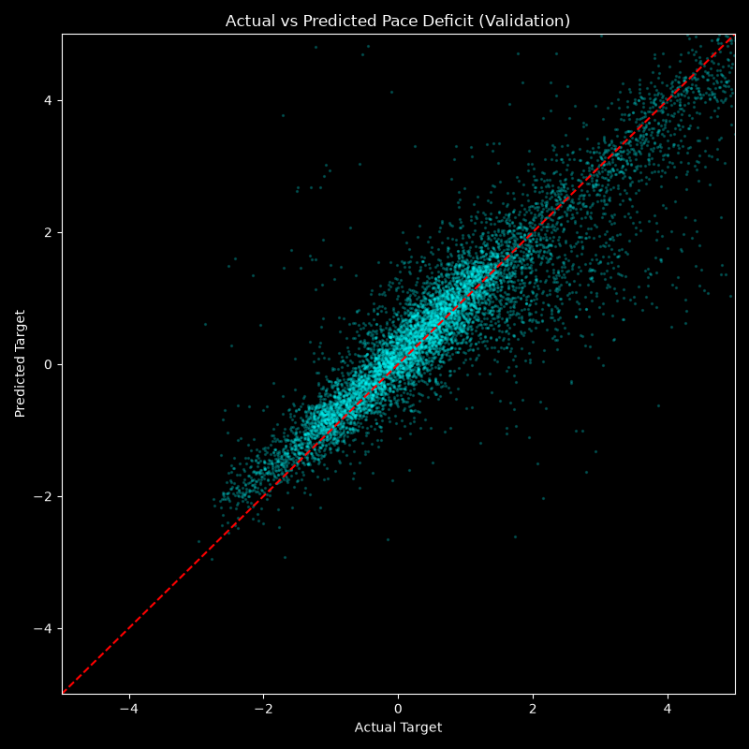
Above is the Actual Vs Predicted speed decline due to the Tyre Degradation over time.

